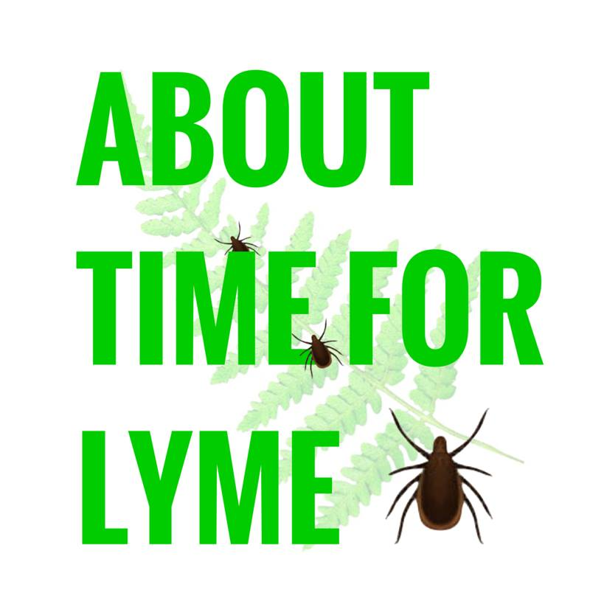

About Time for Lyme was set up to increase awareness and education of the growing problem of tick-borne diseases in the UK. Our aim is to encourage people to continue to enjoy the outdoors by empowering them with the basic information that will allow them to do so. We produce educational materials, hold awareness events (and present at various other events), work alongside other Lyme disease organisations, and lobby for change and improvements in the approach towards tick-borne diseases in the UK.
We are based in The New Forest and are fortunate to have the support of The National Park and The New Forest MPs, however our work covers the whole of the UK. We are proud to be working closely with the charity, Vis-a-Vis Symposiums.

Why is it about time for Lyme?
- In 1993, NATO held a symposium in London, at which scientists warned the UK Government about the threat posed by Lyme disease in the UK. The recommendations included warning the British public of the risk and addressing the inadequacies in testing and treatment.
- 25 years later, the UK is faced with the same, yet now more acute, issues.
- The UK tick population continues to increase at a fast rate, with climate change contributing to the problem. In 2015, The Big Tick Project confirmed that ticks were found in every part of the UK, and increasingly so in urban areas.
- In the absence of any Government-led awareness schemes, the vast majority of the British public remain unaware and ill informed of this growing risk to public health.
- Meanwhile, the NHS does not provide training for doctors, leaving them ill equipped to deal with tick-borne diseases.
- The recently drafted NICE guidelines fall short in several areas and fail to provide a satisfactory and proportionate response to the scale and severity of the problem. Conclusions have been drawn from a limited pool of sources.

What is Needed:
- Awareness and educational initiatives to reach the whole of the British public, in order to reduce the incidence of cases becoming unnecessarily serious.
- Compulsory training for medical professionals in the area of tick-borne diseases, in order that doctors no longer have to rely solely on unreliable serology testing. This training should take into account the latest global research.
- Significant improvements in both the testing and treatment options available.
- UK-specific research – provisions must be made to improve the rate of research progressing into clinical settings, rather than it being a case of research for research sake.

